Project Design Phase-II
Technology Stack (Architecture & Stack)

Date | 28 February 2026
Team ID | LTVIP2026TMIDS43269
Project Name | Flight Finder: Navigating Your Air Travel Options
Maximum Marks | 4 Marks

Technical Architecture:

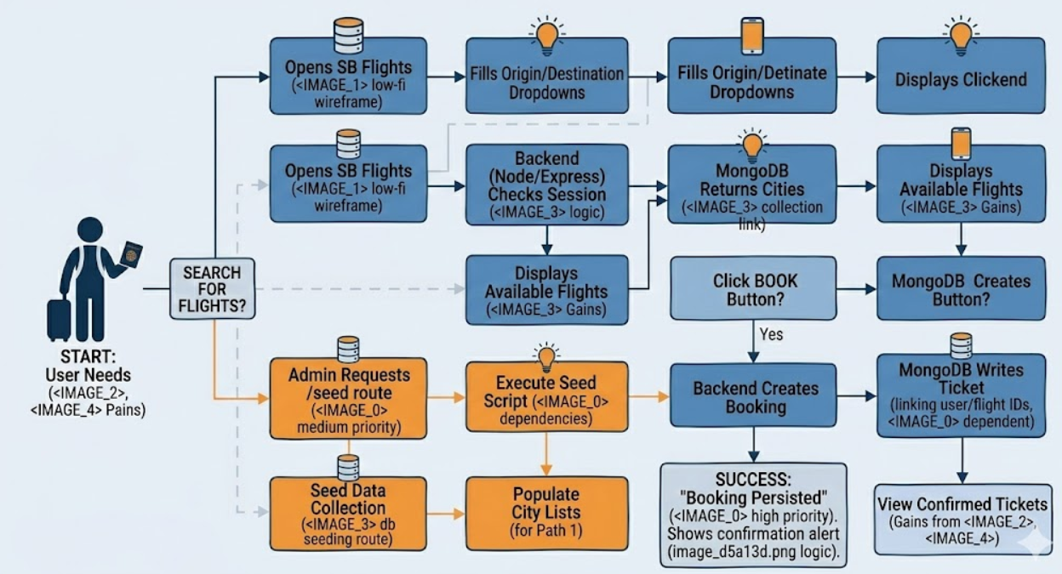
Table-1 : Components & Technologies:
S.No | Component | Description | Technology
1. | User Interface | Responsive flight booking portal. | React.js, Bootstrap, HTML5/CSS3
2. | Application Logic-1 | RESTful API for flight operations. | Node.js, Express.js
3. | Application Logic-2 | Logic for database seeding & cleanup. | Mongoose (ODM)
4. | Application Logic-3 | Flight search & booking processing. | JavaScript (ES6+)
5. | Database | Document-based flight/user storage. | NoSQL (MongoDB)
6. | Cloud Database | Database as a Service (DBaaS). | MongoDB Atlas
7. | File Storage | Local static asset storage. | Local Filesystem
8. | External API-1 | City data/Route mapping. | REST API
11. | Infrastructure | Full-stack cloud deployment. | Render / Vercel

Table-2: Application Characteristics:
S.No | Characteristics | Description | Technology
1. | Open-Source Frameworks | Full-stack MERN libraries. | Mongoose, React-Router
2. | Security | Protected DB connection & session logic. | Dotnet, MongoDB Atlas IP Access
3. | Scalable Architecture | Decoupled Client-Server (3-Tier). | RESTful API Design
4. | Availability | Cloud-based global deployment. | Render / Atlas Cloud
5. | Performance | Non-blocking I/O & JSON exchange. | Node.js Event Loop

